**Angle of movement**

I found the angle of movement depending on inverse kinematics, I assumed that we want to move robot's leg to the point: (57.55, 28) on the cartesian coordinate system. The the value of x is 57.55 and the value of y is 28. As given to us that the length of the robot leg is 64 cm, now we have three values that represent the side lengths of a right-angled traingle. Depending on the trigonometric functions of right-angled traingle we can find the angle of the movement by using the following formula:

sin 𝜃 = opposite side/ hypotenuse

sin 𝜃 = 28/64

𝜃 = arcsin(28/64)

𝜃 = 25.94°

**see the representation of points on the Cartesian coordinate system.**

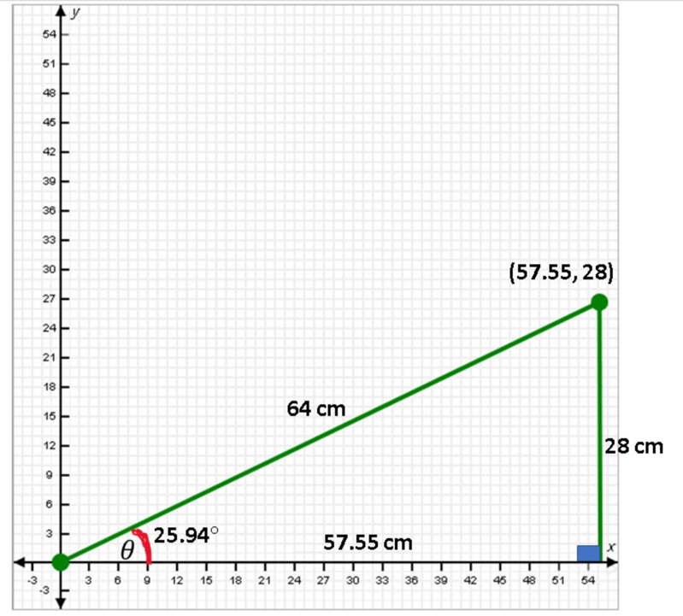

## Animate robot leg

* access my 3D design for robot legs.

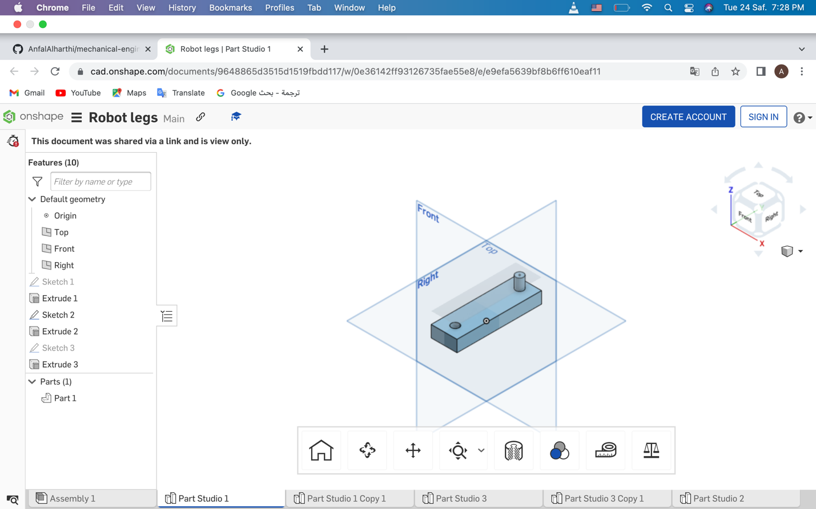

* see the robot leg when the angle is 0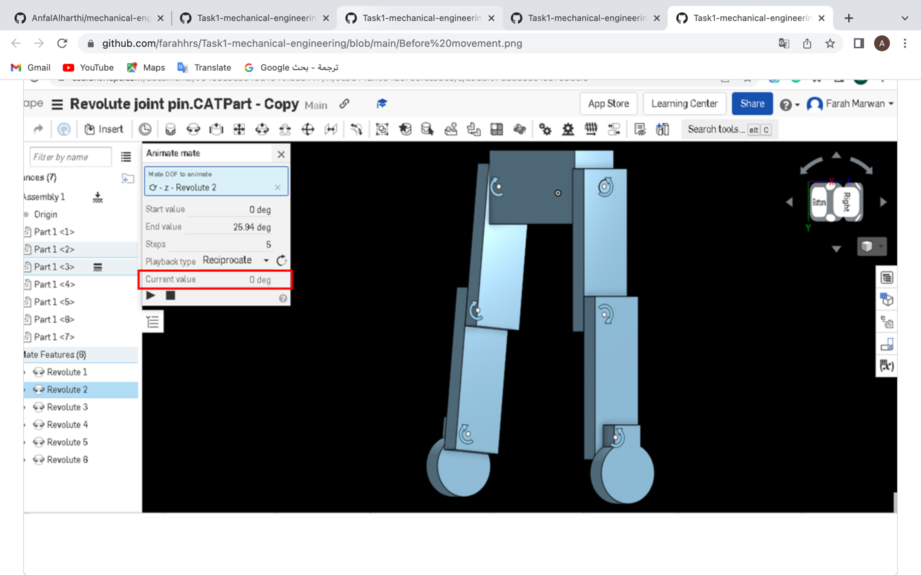
* see the robot leg when the angle is 24.95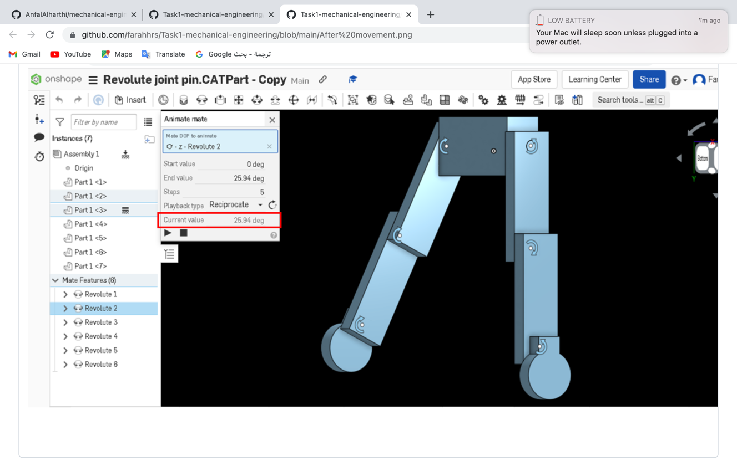

## Parts lengths

see my suggestion for parts lengths of the robot leg.

